AI ASS 14.1
Name: K . UMA MAHESHWARI
H.T.N0:2303A52430

Batch:44
Task1:portfolio website Prompt:
Create a modern personal portfolio website using HTML, CSS, and JavaScript with About, Projects, and Contact sections, clean colors, typography, and a responsive Flexbox/Grid layout.
Add smooth scrolling navigation to enhance user experience with a simple and visually appealing design.
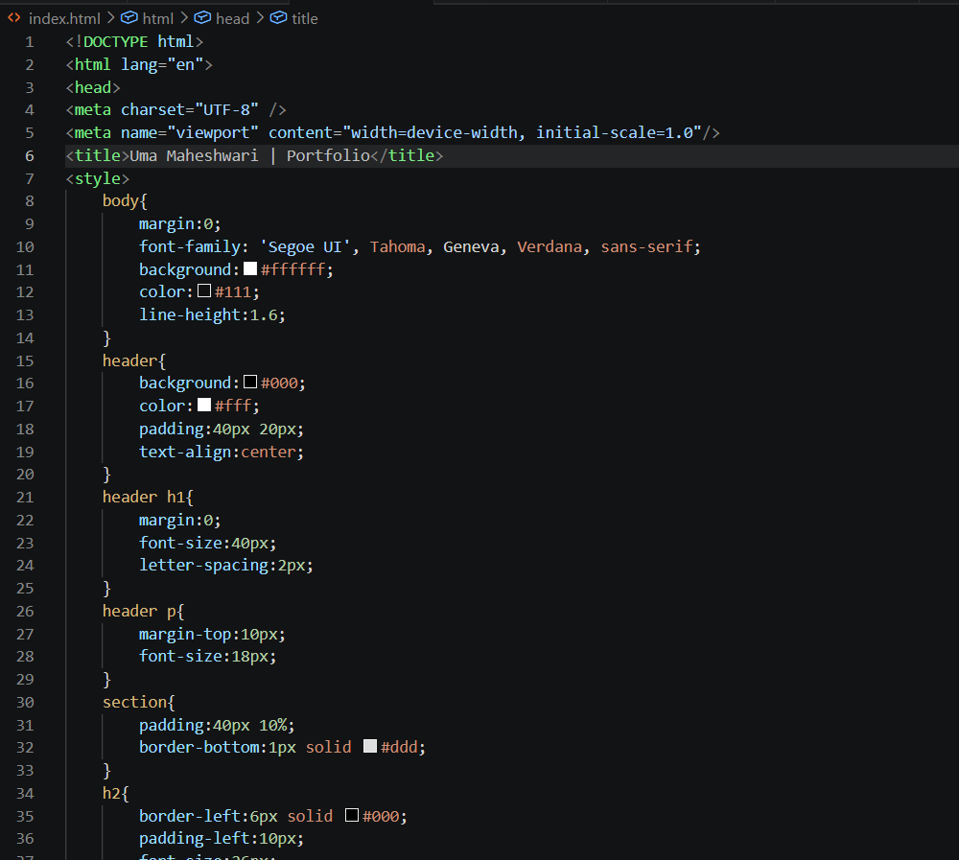
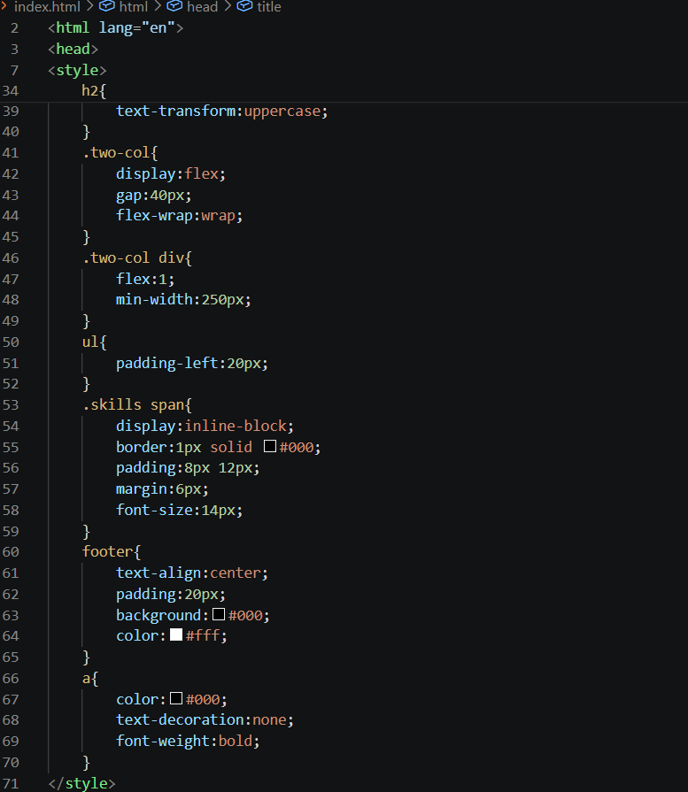
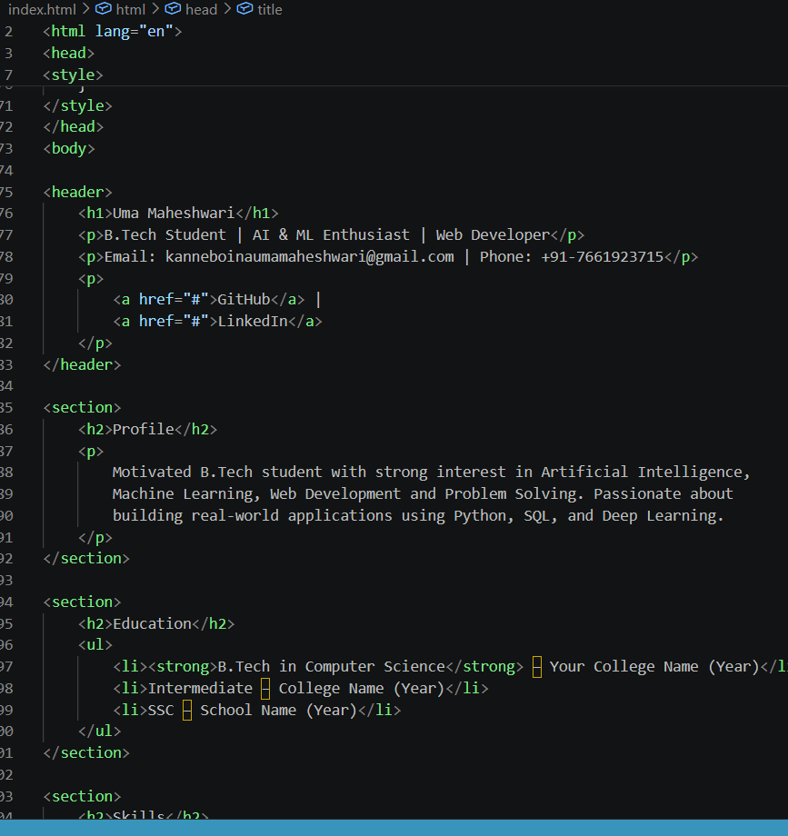

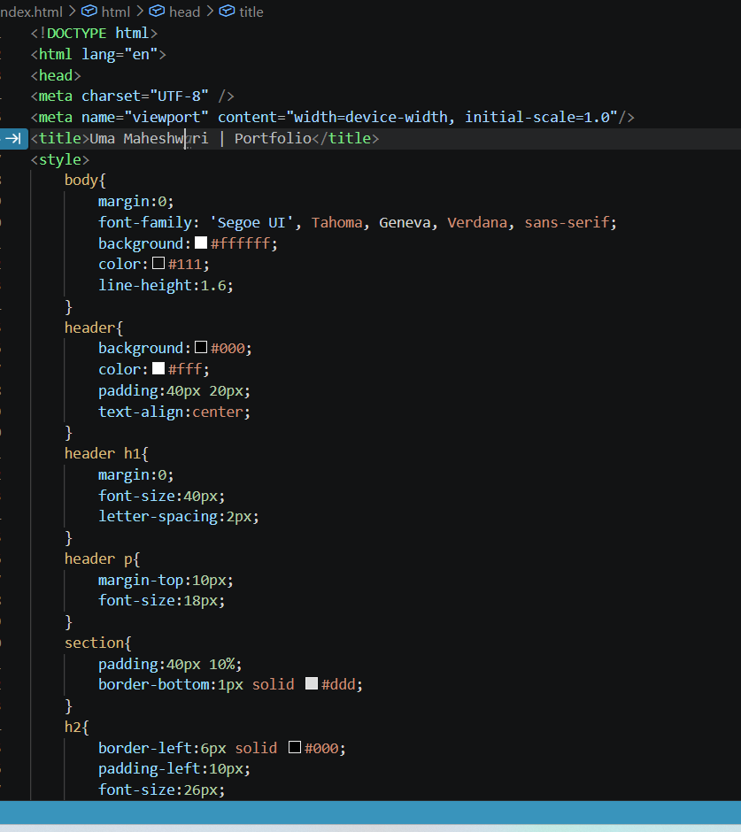
OUTPUT:
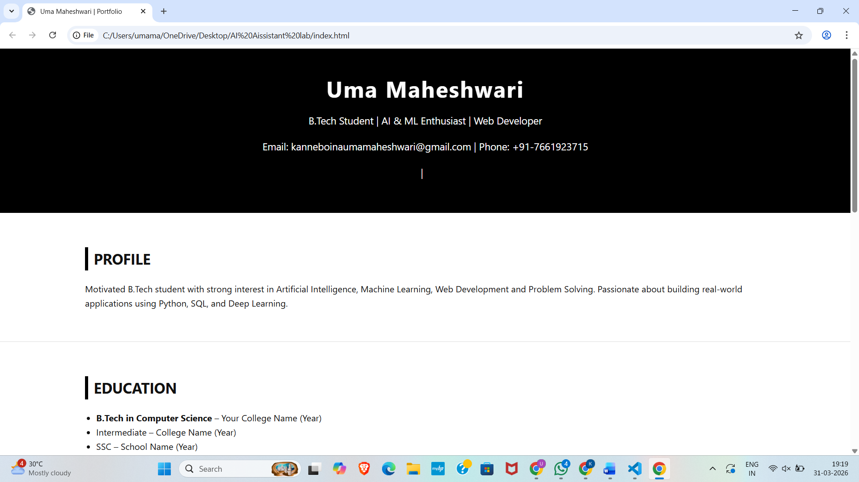
v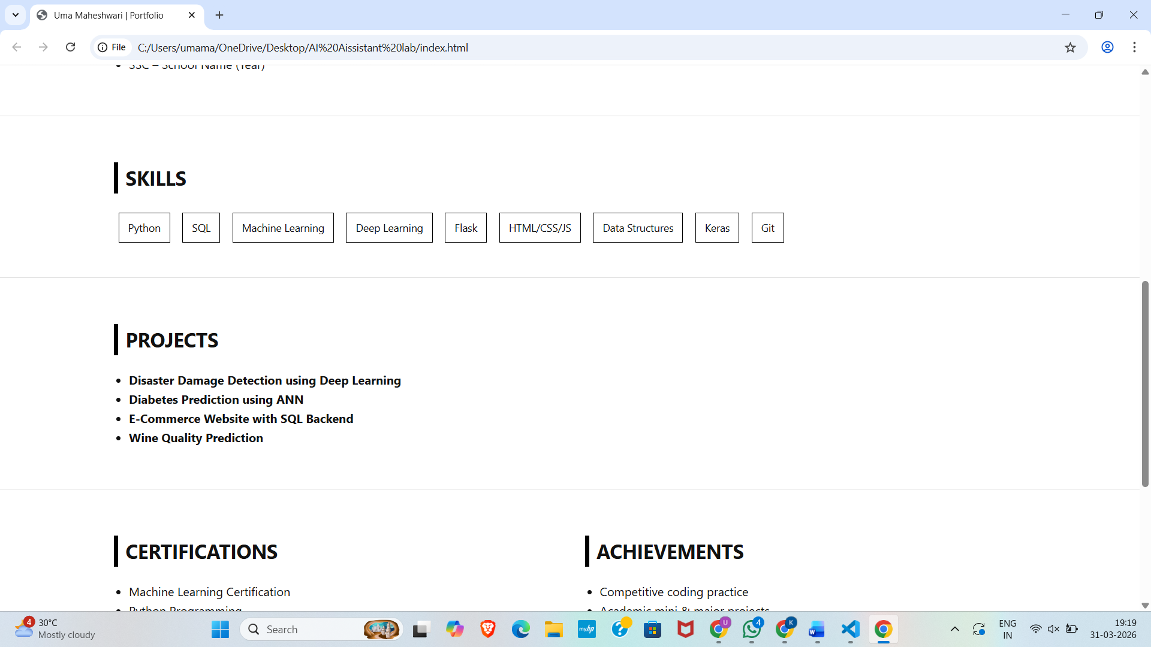
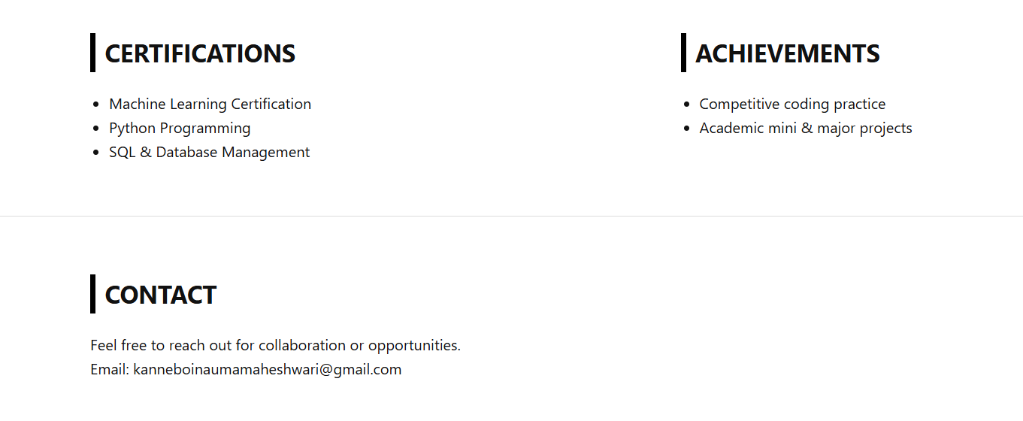

Task2: Online Store Product Page
Prompt:
Design responsive product page with HTML, CSS (BEM), and JavaScript showing product details and an “Add to Cart” alert.

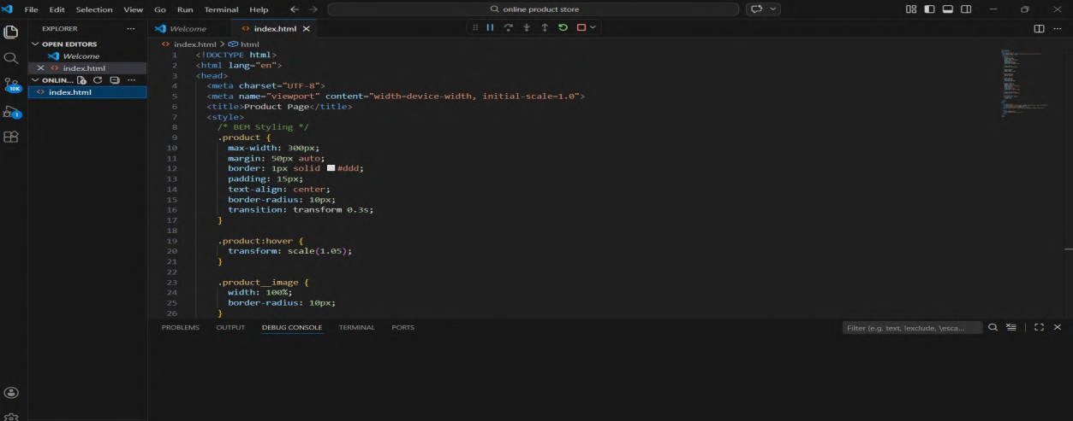
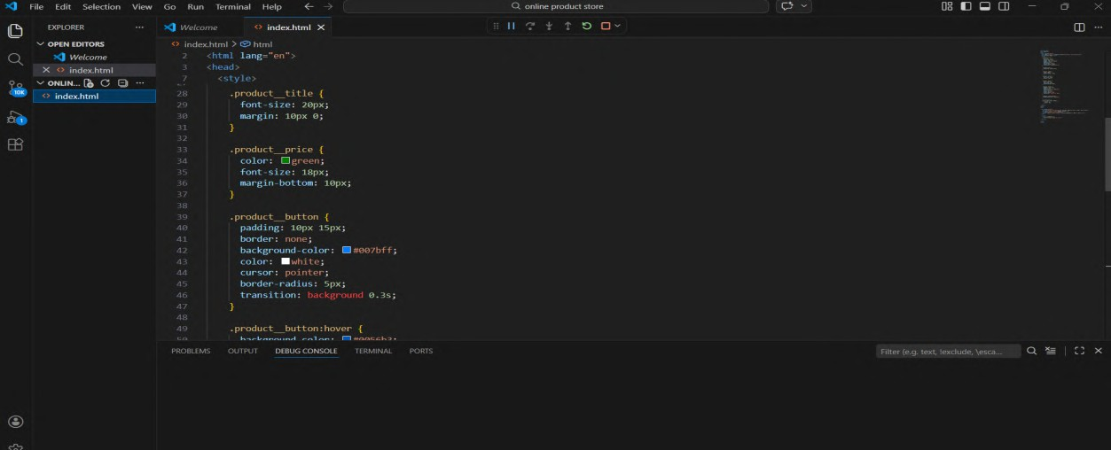
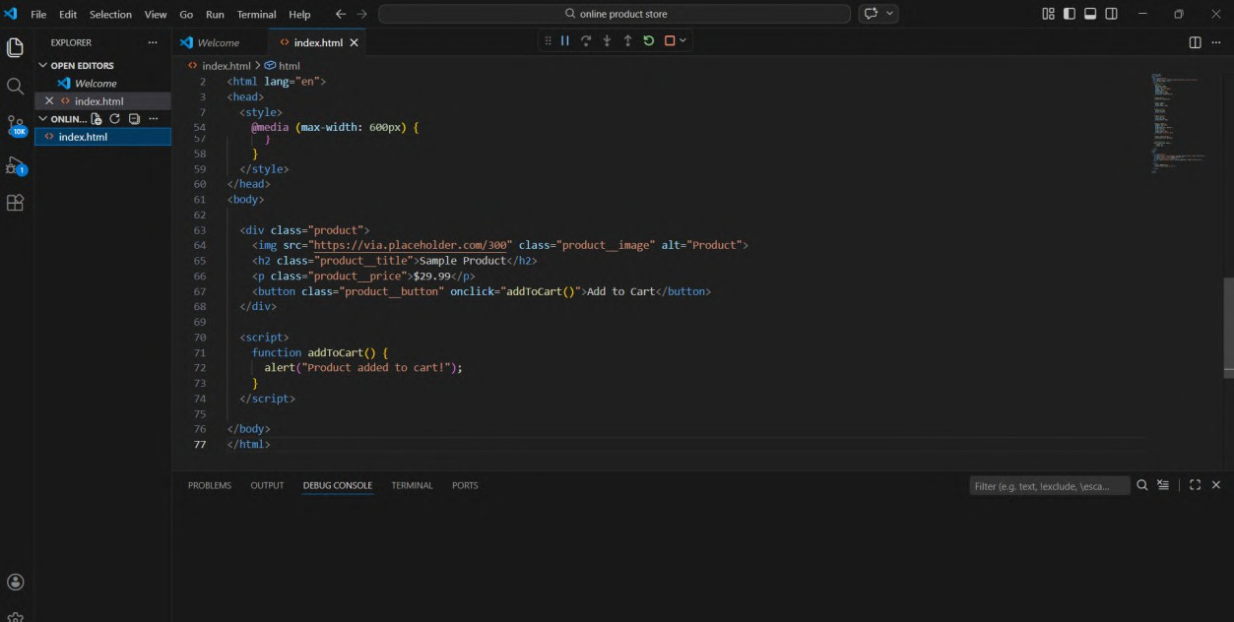

Output:
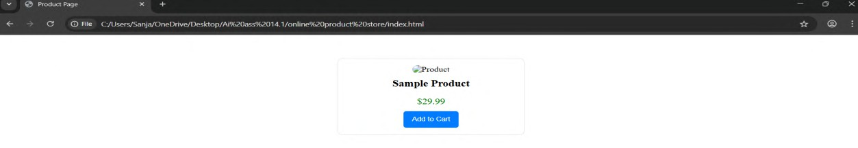

Task3: Event Registration Form
Prompt:
Create a styled, accessible event registration form with HTML, CSS, and JavaScript including validation for required fields before

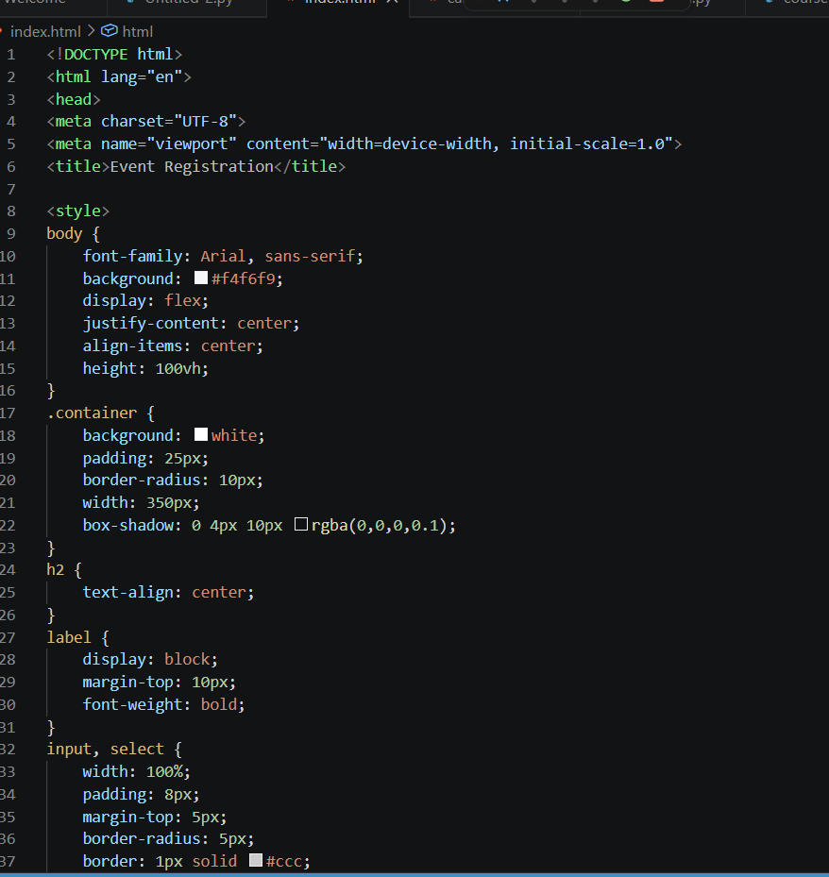
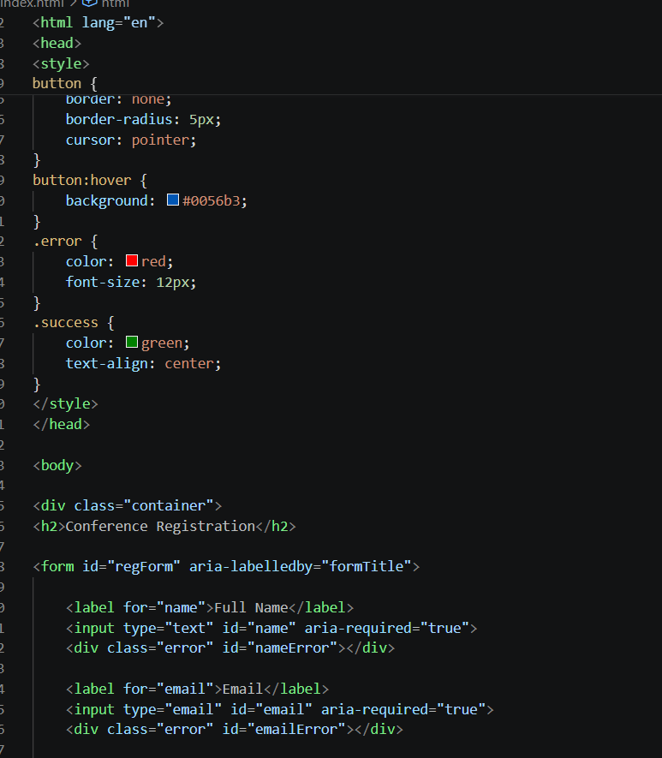
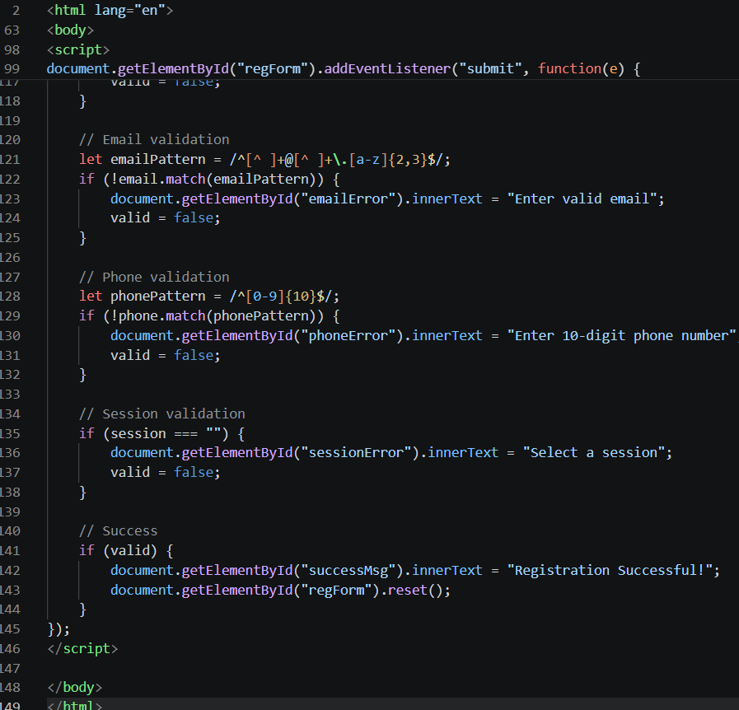
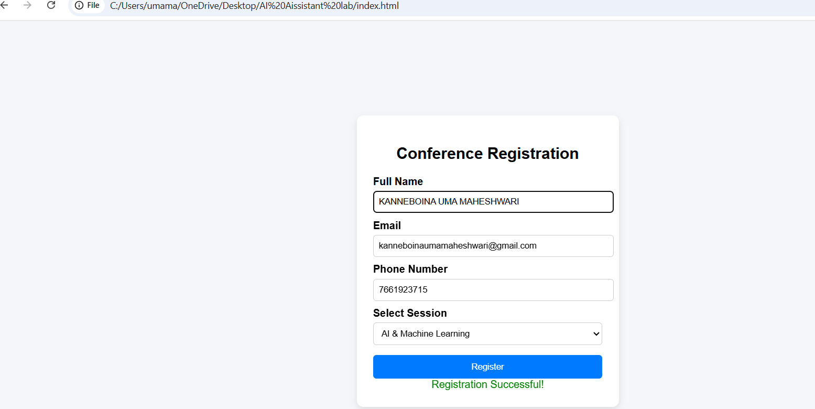

Task4: Resume Website Prompt:
Create a one-page resume website using HTML, CSS, and JavaScript with CSS Grid, smooth scrolling, and sections for Profile, Skills, Education, and Experience.
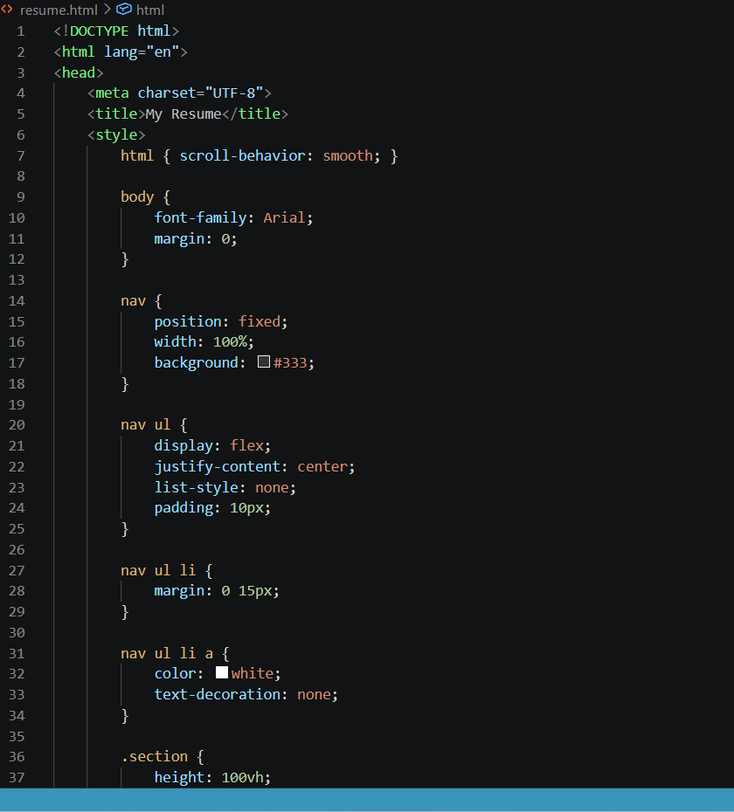
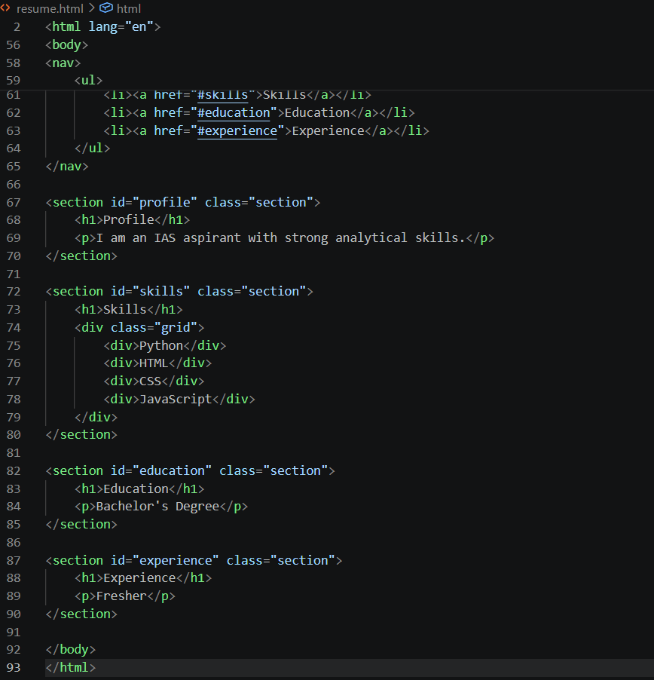
Output
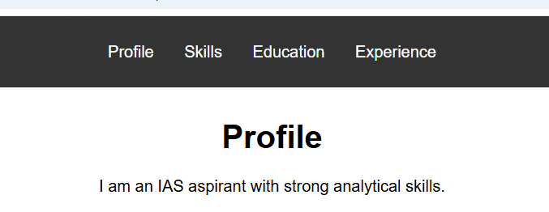
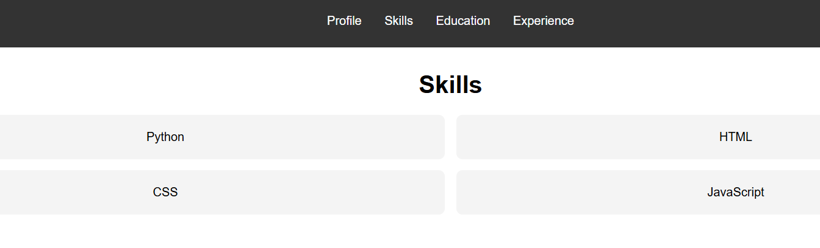
Task5: Restaurant Menu Page
Prompt:
Design a responsive restaurant menu page using HTML and CSS with a card layout, warm color palette, and hover effects displaying food details.
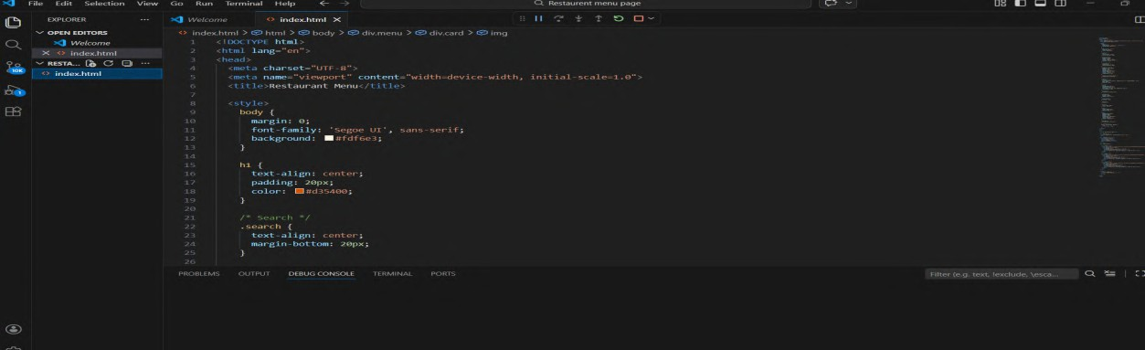
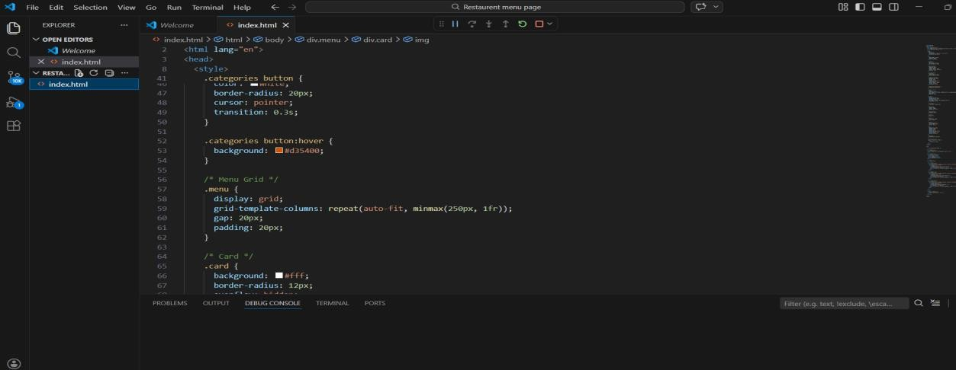
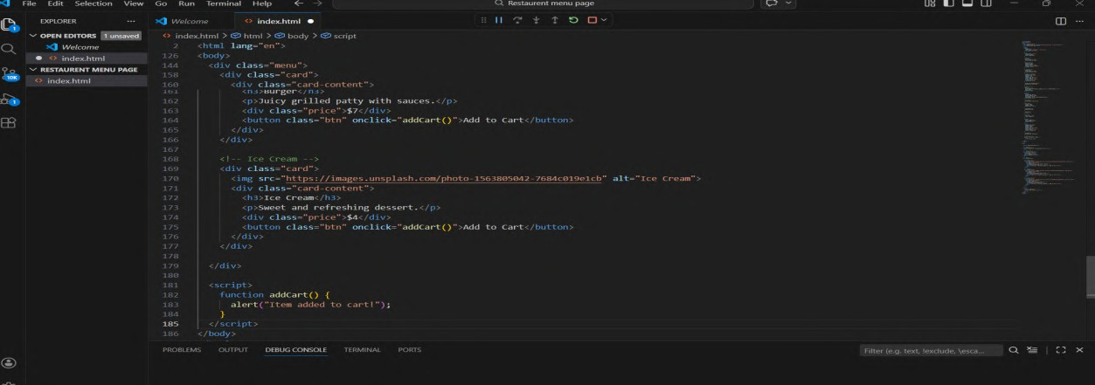

Output:
